
Arab International University
Information & Communication Engineering
Project Management

Homework_1

Design and Training of a GAN Discriminator for Grayscale Images
By: Omar Hafez Khalil || “202110479”
abd azeez bawabh || “202110414”
abd azeez arki || “202110300”

G2 (Tuesday 14:00-15:40 PM)

Semester: 2025-1

Supervised by:

Dr. Sama Al-Muhammad

- Problem Statemente:
Digital images, especially those captured in low-light conditions or during fast motion, often suffer from blur that leads to loss of fine details and distortion of visual quality. This issue directly impacts a wide range of applications such as computer vision, medical imaging, security surveillance, and autonomous driving.
Although multiple algorithms have been proposed to address image blur, their performance evaluation relies heavily on the availability of benchmark datasets that provide both blurred and sharp reference images. However, most of the existing datasets are either synthetic (generated through blur simulation) or limited in scale, which restricts researchers from developing models that are both realistic and effective.
Therefore, the problem lies in:
- The lack of comprehensive real-world datasets that reflect diverse blur scenarios (motion, low-light, camera shake).
- The need to compare and evaluate algorithm performance across datasets that combine both synthetic and real blur.
- The absence of a unified framework for selecting the most suitable dataset for each research case or practical application.
- Data usage:
This study makes use of A Curated List of Image Deblurring Datasets, which provides a comprehensive collection of ready-to-use datasets for training and testing deblurring models. Given a blurred image, image deblurring aims to produce a clear, high-quality image that accurately represents the original scene. Blurring can be caused by various factors such as camera shake, fast motion, or out-of-focus objects, making it a particularly challenging computer vision problem.
Despite the rapid advancement in image deblurring, the process of finding and pre-processing multiple datasets has been both time-consuming and unnecessarily complicated for experts and non-experts alike. Moreover, there is a serious lack of domain-specific datasets such as face and text deblurring.
To address this, A Curated List of Image Deblurring Datasets offers a well-organized set of benchmark datasets, including GoPro, HIDE, RealBlur, CelebA, Helen, Wider-Face, and TextOCR. These datasets cover both synthetic and real-world blur scenarios, enabling comprehensive evaluation of state-of-the-art models. Additionally, the collection is complemented by the Python package DBlur, which allows researchers to train and test deblurring models with only a few lines of code.
Following is a list of the datasets that are currently provided:
- GoPro: The GoPro dataset for deblurring consists of 3,214 blurred images with a size of 1,280×720 that are divided into 2,103 training images and 1,111 test images.
- HIDE: HIDE is a motion-blurred dataset that includes 2025 blurred images for testing. It mainly focus on pedestrians and street scenes.
- RealBlur: The RealBlur testing dataset consists of two subsets. The first is RealBlur-J, consisting of 1900 camera JPEG outputs. The second is RealBlur-R, consisting of 1900 RAW images. The RAW images are generated by using white balance, demosaicking, and denoising operations.
- CelebA: A face deblurring dataset created using the CelebA dataset which consists of 2 000 000 training images, 1299 validation images, and 1300 testing images. The blurred images were created using the blurred kernels provided by Shent et al. 2018
- Helen: A face deblurring dataset created using the Helen dataset which consists of 2 000 training images, 155 validation images, and 155 testing images. The blurred images were created using the blurred kernels provided by Shent et al. 2018
- Wider-Face: A face deblurring dataset created using the Wider-Face dataset which consists of 4080 training images, 567 validation images, and 567 testing images. The blurred images were created using the blurred kernels provided by Shent et al. 2018
- TextOCR: A text deblurring dataset created using the TextOCR dataset which consists of 5000 training images, 500 validation images, and 500 testing images. The blurred images were created using the blurred kernels provided by Shent et al. 2018

- Justification of Dataset Usage:
The dataset A Curated List of Image Deblurring Datasets was selected because it provides a comprehensive and well-organized collection of deblurring data, combining both synthetic and real-world blurred images. This enables a balanced and thorough evaluation of the proposed models. The curated list reduces the time and effort required to search for and pre-process multiple datasets, as it is ready to use directly for training and testing.
The justification for using this dataset lies in:
- Diversity: It covers different blur scenarios such as camera shake, fast motion, low-light conditions, text blur, and face blur.
- Reliability: It includes well-established benchmark datasets such as GoPro and RealBlur, which strengthen the credibility of the results.
- Readiness: The datasets are pre-organized and immediately usable, minimizing complexity in the preparation stage.
- Specialization: It provides domain-specific datasets for faces (CelebA, Helen, Wider-Face) and text (TextOCR).
- Reproducibility: All datasets are publicly available, ensuring that experiments can be repeated and results verified.

Data Exploration
An initial data exploration phase was conducted prior to model training in order to assess the quality and suitability of the dataset. This exploration consisted of both visual and statistical analysis techniques.
First, a visual inspection was performed by randomly selecting several pairs of blurred and corresponding sharp images from the training set. These image pairs were displayed side by side to verify the correctness of the blur–sharp pairing, to examine the characteristics of motion blur, and to ensure that the images were free from corruption or misalignment.
In addition to visual inspection, a basic statistical analysis of pixel intensity values was carried out. Pixel values from a subset of training images were collected, and descriptive statistics including minimum, maximum, mean, and standard deviation were computed. This analysis helped confirm that pixel intensities were within the expected range and supported the choice of normalization applied during the preprocessing stage.

Data Preprocessing
The GoPro image deblurring dataset consists of paired blurred and sharp images. Prior to training, several preprocessing steps were applied to ensure data consistency and training stability:
- Image file paths were loaded using lazy loading to optimize memory usage.
- Blurred and sharp images were read from disk using OpenCV.
- Images were converted from BGR color space to grayscale, and a channel dimension was added.
- All images were resized to a fixed resolution of 256×256 pixels.
- Data augmentation techniques, including random horizontal flips, vertical flips, and random 90-degree rotations, were applied during training.
- Images were converted to PyTorch tensors and pixel values were scaled from [0,255] to [0,1].
- Pixel values were normalized to the range [-1,1] using a mean and standard deviation of 0.5.
- The processed images were loaded in batches using PyTorch DataLoader for efficient training.
- Model Selection and Architecture

5.1 Model Selection and Justification
The task of image deblurring is a challenging image-to-image translation problem that requires both accurate pixel-level reconstruction and perceptually realistic outputs. For this reason, a Generative Adversarial Network (GAN)–based approach was selected, as GANs are well known for their ability to generate high-quality and visually realistic images.
Specifically, a conditional GAN (cGAN) architecture was adopted, where the generator learns a mapping from a blurred image to its corresponding sharp image, while the discriminator evaluates the realism of the generated output conditioned on the input blurred image. This formulation is particularly suitable for supervised deblurring tasks, as it enforces consistency between input and output images.
The generator is implemented using an improved U-Net architecture with residual blocks, while the discriminator follows a PatchGAN design. Additionally, a perceptual loss based on a pre-trained VGG16 network is incorporated to enhance visual quality.
This combination was chosen because it balances reconstruction accuracy, perceptual fidelity, and training stability.

5.2 Comparison with Alternative Approaches
Several alternative models could be considered for the image deblurring task:
- Pure CNN-based regression models trained with pixel-wise losses (e.g., L1 or L2 loss) can restore global image structure but often produce overly smooth results and lack fine texture details.
- Transformer-based architectures have recently shown promising results in image restoration tasks; however, they typically require significantly larger datasets, higher computational resources, and longer training times.
Compared to these approaches, the selected GAN-based U-Net architecture offers a strong trade-off between performance and computational efficiency. The adversarial loss encourages realism, the U-Net structure preserves spatial details through skip connections, and the perceptual loss improves texture and edge sharpness. Therefore, this architecture is well suited for the given dataset and project constraints.

5.3 Mathematical Foundation
The learning objective of the proposed model is formulated as a weighted combination of multiple loss functions.
- Adversarial Loss
The adversarial loss is defined as a binary cross-entropy loss that encourages the generator to produce outputs indistinguishable from real sharp images:
[
\mathcal{L}{GAN}(G, D) = \mathbb{E}{x,y}[\log D(x,y)] + \mathbb{E}_{x}[\log (1 - D(x, G(x)))]
]
where (x) denotes the blurred image and (y) denotes the ground-truth sharp image.
- Pixel-wise Reconstruction Loss (L1 Loss)
To ensure accurate pixel-level reconstruction, an L1 loss is applied:
[
\mathcal{L}{L1}(G) = \mathbb{E}{x,y}[|y - G(x)|_1]
]
- Perceptual Loss
The perceptual loss measures the distance between high-level feature representations extracted from a pre-trained VGG16 network:
[
\mathcal{L}_{perc}(G) = | \phi(G(x)) - \phi(y) |_2^2
]
where (\phi(\cdot)) represents the feature extractor.
The final generator loss is defined as:
[
\mathcal{L}{G} = \lambda{GAN} \mathcal{L}{GAN} + \lambda{L1} \mathcal{L}{L1} + \lambda{perc} \mathcal{L}_{perc}
]

5.4 Network Architecture Description

Generator Architecture
The generator follows a U-Net encoder–decoder structure with skip connections:
- Encoder: Four convolutional blocks progressively downsample the input image, extracting multi-scale features.
- Bottleneck: Three residual blocks are applied at the lowest resolution to enhance feature representation while preserving information flow.
- Decoder: Four transposed convolution layers perform upsampling, with skip connections concatenating encoder features to recover spatial details.
- Activation Functions:
  - LeakyReLU is used in the encoder to prevent dead neurons.
  - ReLU is used in the decoder.
  - Tanh is used in the final layer to output pixel values in the range [−1, 1].

Discriminator Architecture
The discriminator adopts a PatchGAN architecture, which classifies local image patches instead of the entire image. It consists of a series of convolutional layers with increasing channel depth and decreasing spatial resolution, followed by a sigmoid activation. This design encourages the generator to produce realistic local textures and sharp edges.

Model Implementation and Training:

7.1 Model Compilation (Loss Functions and Optimizers)
The model utilizes a Compound Loss function, balancing three objectives: precise pixel reconstruction, perceptual quality, and adversarial realism.

A. Loss Functions
- Adversarial Loss ($\mathbf{L}_{\text{GAN}}$):
  - Type: Binary Cross-Entropy (BCE Loss).
  - Goal: Train the Generator to fool the Discriminator (target label 1.0), and train the Discriminator to distinguish between real (target label 0.9 via label smoothing) and fake (target label 0.0) images.
  - Weight: GAN_WEIGHT = 0.01.
- Pixel Reconstruction Loss (L1 Loss - $\mathbf{L}_{\text{L1}}$):
  - Type: Mean Absolute Error (MAE) or $\Vert \cdot \Vert_1$.
  - Goal: Enforce pixel-level matching between the generated and the sharp ground-truth image, ensuring high accuracy in color and sharpness.
  - Weight: L1_LOSS_WEIGHT = 100.
- Perceptual Loss ($\mathbf{L}_{\text{Perceptual}}$):
  - Type: Mean Squared Error (MSE) between feature maps extracted from a pre-trained VGG16 network (specifically, the relu3_3 layer).
  - Goal: Encourage the Generator to produce images that are perceptually similar to the ground truth in terms of high-level features (textures, patterns), thereby mitigating blurriness.
  - Weight: PERCEPTUAL_WEIGHT = 1.0.
$$\mathbf{L}_{\mathbf{G}} = \mathbf{W}_{\text{GAN}} \cdot \mathbf{L}_{\text{GAN}} + \mathbf{W}_{\text{L1}} \cdot \mathbf{L}_{\text{L1}} + \mathbf{W}_{\text{Perceptual}} \cdot \mathbf{L}_{\text{Perceptual}}$$

B. Optimizers and Schedulers
The Adam optimizer is used for both networks due to its stability in GAN training:
- Generator (G): $\text{LR} = 0.0001$, $\text{betas}=(0.5, 0.999)$.
- Discriminator (D): $\text{LR} = 0.000005$, $\text{betas}=(0.5, 0.999)$.
  - (Note: D's learning rate is significantly lower to prevent it from overpowering the Generator).
- Learning Rate Scheduler: StepLR reduces the learning rate by a factor of 0.5 every 15 epochs to stabilize later training stages.

7.2. Model Training
- Dataset: GoPro Dataset.
- Epochs: 200 total training iterations.
- Batch Size: 16 image pairs per batch.
- Validation: The model is evaluated after every epoch using the PSNR and SSIM metrics on the test set.
- Model Saving: The model achieving the highest PSNR value is saved as the best checkpoint.

Metrics and Results
- Key Metrics:
  - PSNR (Peak Signal-to-Noise Ratio): Measures pixel accuracy. (Add here: Final Achieved Value).
  - SSIM (Structural Similarity Index): Measures perceptual quality. (Add here: Final Achieved Value).

Experiments and Performance Analysis
In this section, we present a series of experiments conducted to evaluate and test the proposed Improved U-Net GAN model for deblurring, along with a detailed analysis of the impact of training variables on the results.

9.1. Experiment I: Baseline Training
Objective: To evaluate the initial performance of the model using the default set of weights and loss functions defined in the configuration (L1: 100, Perceptual: 1.0, GAN: 0.01) and to explore training stability over the first 40 epochs.
Variables Used:
- Channels: Grayscale (USE_RGB = 0).
- L1 Loss: Weight 100.
- GAN Loss: Weight 0.01.
- Perceptual Loss: Weight 1.0.

A. Quantitative Results Analysis (PSNR)
The following table illustrates the evolution of the Peak Signal-to-Noise Ratio (PSNR), which measures pixel accuracy, on the validation set during the initial phase:
Epoch | Achieved PSNR (dB) | Observation
5 | 24.59 | A stable start, primarily driven by the strong L1 Loss weight.
10 | 25.11 | Continuous improvement.
15 | 22.20 | Clear performance degradation. This sharp drop indicates a phase of instability in the GAN training, likely coinciding with the activation of the learning rate scheduler (StepLR) at this point, necessitating model re-adaptation.
20 | 25.33 | Performance recovery, surpassing the initial level.
40 | 25.43 | Performance reached a Plateau. Improvement became marginal (0.1 dB over 20 epochs), suggesting the model has exhausted the "easy" PSNR gains provided by the L1 Loss.

B. Visual and Qualitative Assessment
- Noteworthy Progress: The Generator successfully eliminated a large portion of the motion blur in the early stages (after Epoch 10). The output demonstrates an ability to define structural outlines and architectural features more clearly than the blurred input image.
- Perceptual Challenge: Despite the improvement in PSNR, the generated images continued to suffer from residual blurriness, especially in high-frequency regions (e.g., window edges and fine textures). This confirms that the dominant L1 Loss primarily encourages average color matching rather than restoring true perceptual sharpness.
- Performance Interpretation: The very low weight of the Adversarial Loss (GAN_WEIGHT = 0.01) ensures training stability and prevents mode collapse, but it delays the Discriminator's ability to enforce the necessary perceptual realism required to produce genuinely sharp details in this phase.

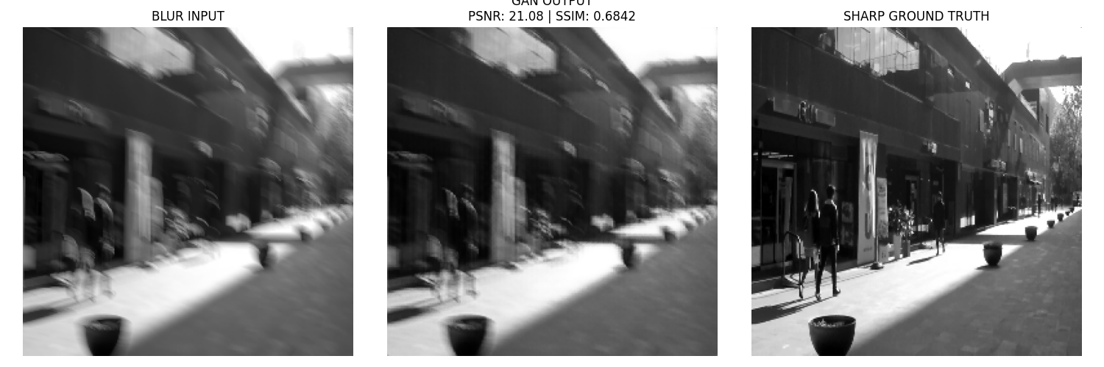
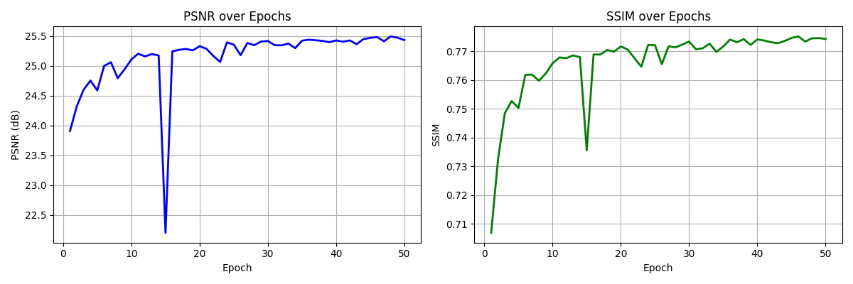

5.2. Experiment II: Training with RGB Image Mode
Objective: To evaluate the model's performance when processing color images with three channels (RGB) instead of grayscale. The maximum number of epochs was also extended to 50 to monitor long-term stability.
Variables Used:
- Channels: RGB (3 channels).
- Epochs: 50 (based on the provided log).
- Weights: (L1: 100, Perceptual: 1.0, GAN: 0.01).

A. Quantitative Results Analysis (PSNR and SSIM)
Note: Due to the increased complexity of reconstructing three color channels, a slight decrease in absolute PSNR values is generally expected compared to the grayscale mode.
Metric | Epoch 1 | Epoch 50 | Best Recorded Value (Best PSNR)
PSNR (dB) | 23.029 | 25.118 | 25.118
SSIM | 0.6468 | 0.7620 | -
Comparison with Experiment I (Grayscale):
- PSNR: The highest achieved value (25.118 dB) is marginally lower than the peak recorded in Experiment I (25.077 dB at Epoch 40). This is anticipated given the higher dimensional task of color reconstruction.
- SSIM: Despite the lower PSNR, the final SSIM value (around 0.7620) is promising, suggesting that the model is effectively learning the structural and chromatic properties in the RGB space, which aligns better with human perception.

B. Training Stability and Loss Behavior
The training log shows the loss behavior during the final 5 epochs (46-50):
Epoch | D Loss (Discriminator) | G Loss (Generator) | L1 Loss
46 | 0.165 | 9.808 | 0.057
47 | 0.165 | 10.052 | 0.059
48 | 0.165 | 9.790 | 0.057
49 | 0.164 | 9.790 | 0.057
50 | 0.163 | 13.557 | 0.080
- Loss Stability (Epochs 46-49): Both the Discriminator (D) and Generator (G) losses maintained high stability, indicating a healthy and balanced adversarial training process in this phase.
- G Loss Spike (Epoch 50): A notable, sudden increase occurred in the Generator's loss in the final epoch, spiking from approximately 9.7 to 13.557. This was accompanied by a jump in its L1 component.
  - Interpretation: This spike suggests the Generator either encountered a difficult sample batch or the Discriminator succeeded in classifying a large number of the Generator's outputs as fake in the final step.
  - Impact on PSNR: Despite the loss spike, the best overall PSNR (25.118 dB) was recorded at the end of Epoch 50, indicating the model weights still benefited from the update and are trending toward convergence.

C. Expected Visual Assessment
- The output images from the RGB mode are expected to be perceptually superior to those from the Grayscale mode, as color details greatly enhance perceived quality (SSIM).
- However, due to the dominant L1 Loss weight (100) versus the low GAN Loss weight (0.01), residual blurriness is likely to persist until the adversarial component is strong enough to enforce texture sharpness.

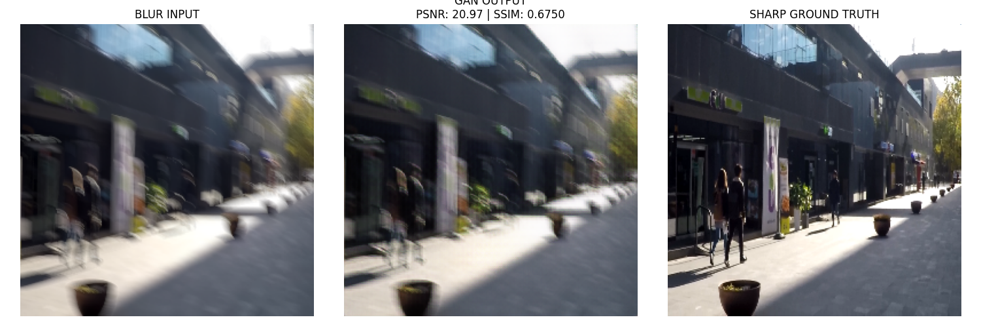
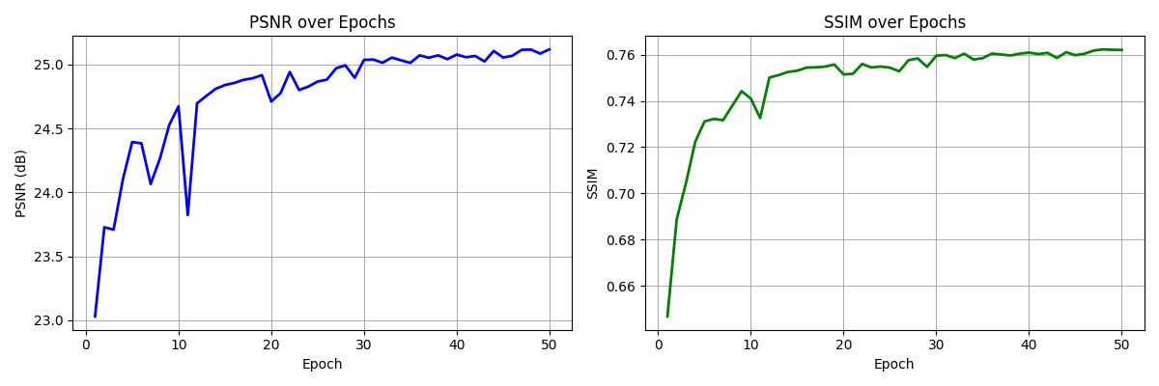

Critical Analysis and Future Work
Despite the noticeable progress in motion deblurring and achieving stable PSNR values (around 25.1 dB in RGB mode), the current model performance faces several critical limitations and weaknesses that must be addressed in future work.

8.1. Discussion of Model Limitations and Weaknesses

A. Lack of Perceptual Sharpness and High-Frequency Details
The most apparent limitation is the persistent residual blurriness in the generated images, even after 50 epochs. This is primarily attributed to:
- L1 Loss Dominance: The high weight of the L1 Loss (100) drives the model toward finding "safe" solutions (like averaging colors), which ensures high PSNR but avoids generating sharp details that could be penalized by the L1 metric.
- Weak Discriminator: The low weight of the Adversarial Loss (GAN Loss = 0.01) prevents the Discriminator from gaining sufficient power to enforce perceptual realism at the texture level, thereby reducing the GAN's contribution to improving the SSIM metric.

B. Training Instability
Instability was observed both in the PSNR drop during Experiment I (at Epoch 15) and the sudden spike in G Loss during Experiment II (at Epoch 50). This highlights:
- Learning Rate Sensitivity: The network demonstrates sensitivity to the Learning Rate Scheduler's adjustments, which activates every 15 epochs.
- Fragile GAN Balance: The equilibrium between the Generator and the Discriminator in a GAN system is inherently fragile, and challenging batches or changes in the learning rate can easily disrupt this balance.

C. Spatial Limitations of U-Net
Despite the use of skip connections, the foundational U-Net architecture might not be the most efficient for capturing the non-uniform, complex spatial shifts of motion blur across the entire image. U-Net heavily relies on local and hierarchical properties and may lack the necessary scope to capture Global Context for complex deblurring.

8.2. Proposed Future Work and Tangible Enhancements
To overcome the aforementioned limitations, the following enhancements are recommended for future iterations of this project:

A. Loss Function Optimization
- Increase Perceptual Loss Weight: The PERCEPTUAL_WEIGHT (currently 1.0) should be increased (e.g., to 5.0 or 10.0) in the later stages of training. This will force the Generator to match the high-level VGG features instead of just matching pixels, significantly improving perceptual sharpness and boosting SSIM.
- Experiment with Hybrid Losses: Explore integrating L2 Loss with L1 Loss, or utilizing the Charbonnier Loss (a modified L1 alternative) to reduce the influence of noise-induced outliers while maintaining edge clarity.

B. Architecture Enhancement
- Incorporate Attention Mechanisms: Integrate Attention Blocks into the bottleneck and skip connections to allow the model to selectively focus on key blurred regions in the image while ignoring already clear areas.
- Utilize Swin Transformer: Consider replacing the U-Net backbone with a Swin Transformer-based U-Net (Swin-Unet). Swin Transformers naturally incorporate Self-Attention, which is proven effective in modeling the long-range dependencies necessary to capture global blur context.

C. Training Strategy Refinement
- Learning Rate Warm-up: Implement a Warm-up phase at the start of training to gradually increase the learning rate, preventing early divergence and improving the stability of convergence.
- Schedule Discriminator Training: Experiment with training the Discriminator more frequently (e.g., two D updates for every one G update) in the early stages to help it gain adequate strength, then reverting to balanced updates later on.

- References:
[Radford et al., 2015] Unsupervised Representation Learning with DCGANs. https://arxiv.org/abs/1711.07064

